

**“RHYTHMIC TUNES: YOUR MELODIC COMPANION”**





**TEAM MEMBERS**

Yuvaraj M (TL)

Senthil kumaran P

Sanjay R

# Introduction

## Welcome to Rythimic Tunes

Rythimic Tunes is a music streaming application built with React.js. Our app is designed to provide a seamless and immersive musical experience, offering an intuitive interface innovative features that transform how users enjoy music. With a focus on both functionality and user experience, Rythimic Tunes blends the latest web technologies to bring users a dynamic platform where they can discover, enjoy, and personalize their music journey. Whether youCre discovering new hits or revisiting timeless classics, our app ensures a smooth and enjoyable musical experience, tailored just for you.



# Project Goals h Objective

User-Friendly Interface: Easy-to-navigate for exploring and managing music. Comprehensive Music Streaming: Advanced search features for easy discovery. Modern Tech Stack: Built with React.js for a smooth experience.





**Key Features**

Song Listings: View detailed information like title, artist, and genre. Playlist Creation: Create personalized playlists.

Offline Listening: Download songs for offline use. Search Functionality: Search by song, artist, or genre.

# Pre-Requisites

**Tools h Software**

Node.js & npm

Node.js: A JavaScript runtime for executing JavaScript code server-side.

npm: The Node.js package manager used to install and manage dependencies.

Git for Version Control

Git enables version control and team collaboration Development Environment (IDE/Code Editor)

Recommended editors for coding: Visual Studio Code

## Technologies h Libraries

React.js

React is the core library used to build the user interface, enabling reusable components and dynamic web apps.

JSON Server

JSON Server: A quick and easy way to create a mock REST API to simulate backend requests.

Libraries & Frameworks React Router Dom React Icons

Bootstrap/Tailwind CSS

.

.





**Project Structure**

## Key project files include app.component.css and src/app/app.component.

**Maintain a clear folder structure for better code management.**





**Milestones**

**1.Project Setup and Configuration**

 Project Setup (Installing dependencies, configuring the environment).

## 2.Project Development

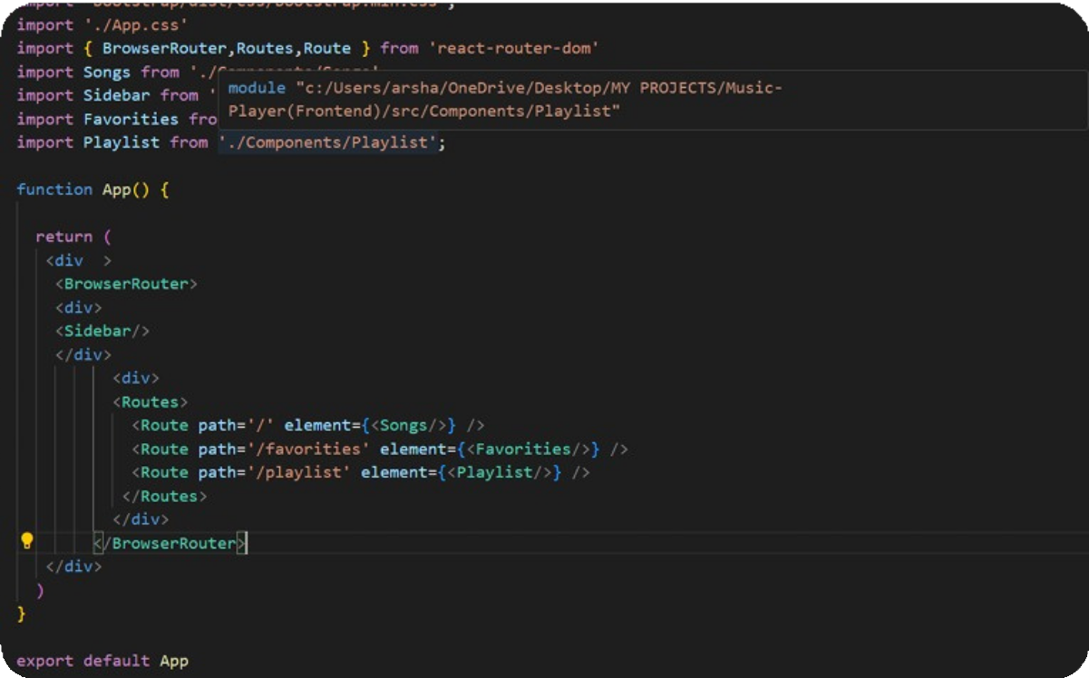 Project Development (Setting up routing, fetching and displaying data).





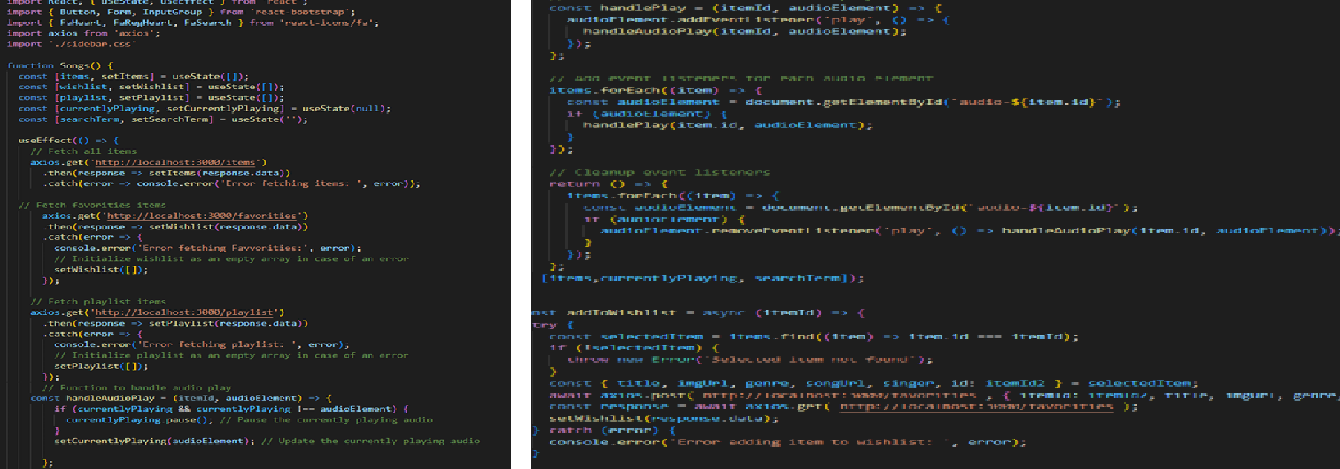

**Fetching Songs**







**Fetching Songs: Using Axios to fetch song data.**







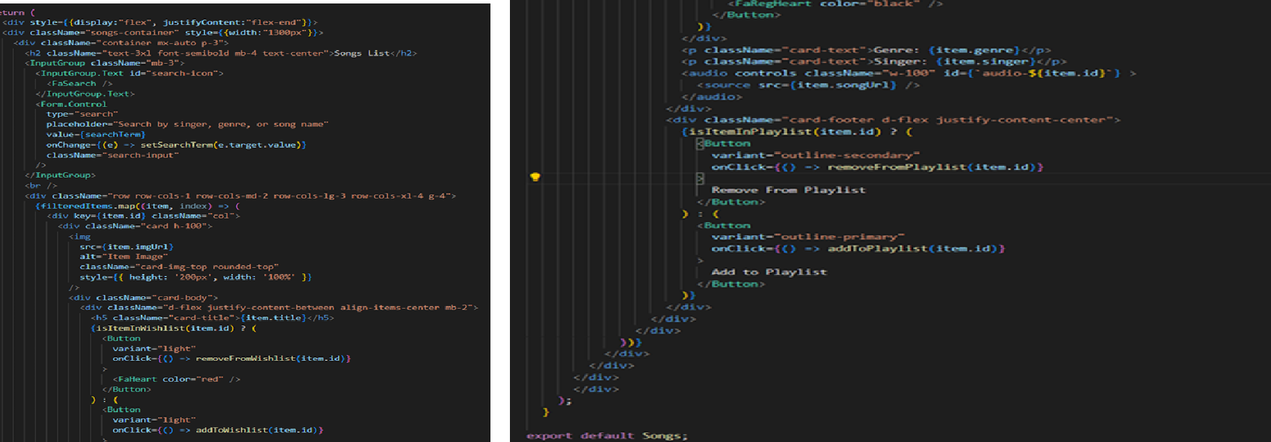

**Frontend Code For Displaying Songs**



# Project Execution

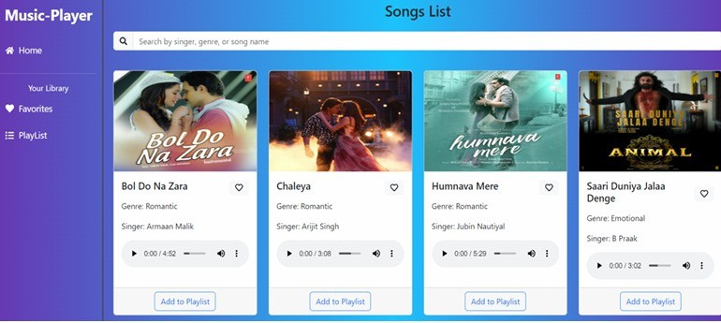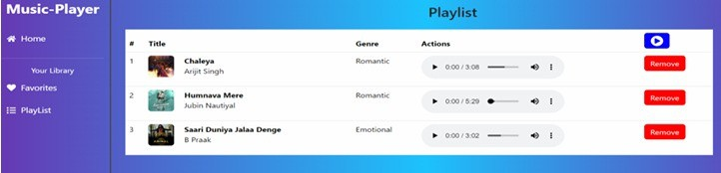

**Hero components**



**Playlist**



# Project Execution

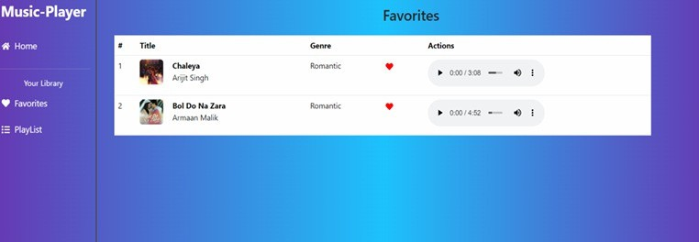

**Favorites**









# Conclusion



 Rythimic Tunes is a cutting-edge music streaming application developed using React.js, delivering a modern, user-friendly, and interactive music experience.

 With features like playlist creation, search functionality, offline listening, and personalized recommendations, the app is designed to enhance the musical journey for all users.

 The project leverages a powerful tech stack including React, React Router, Axios, and JSON Server to ensure smooth functionality and efficient data handling.







 

**Thank You!**